**Module 4 -VPC**

**CASE STUDY**

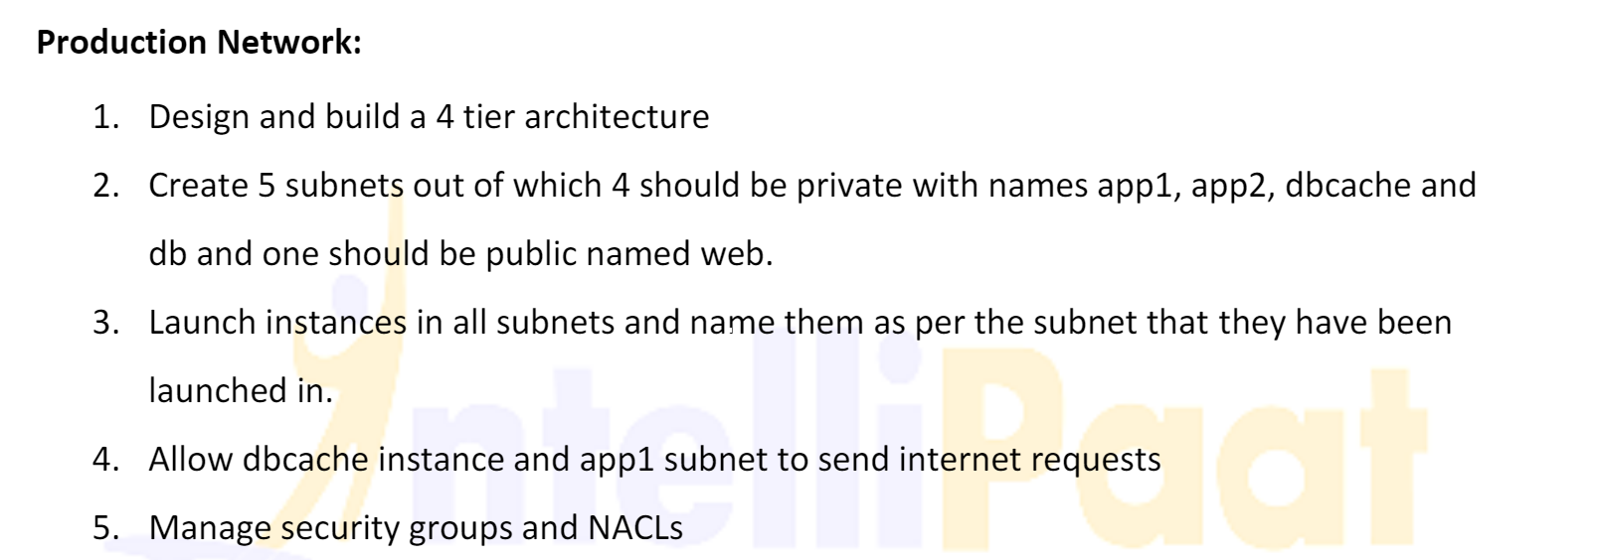

* **Creation of VPC**

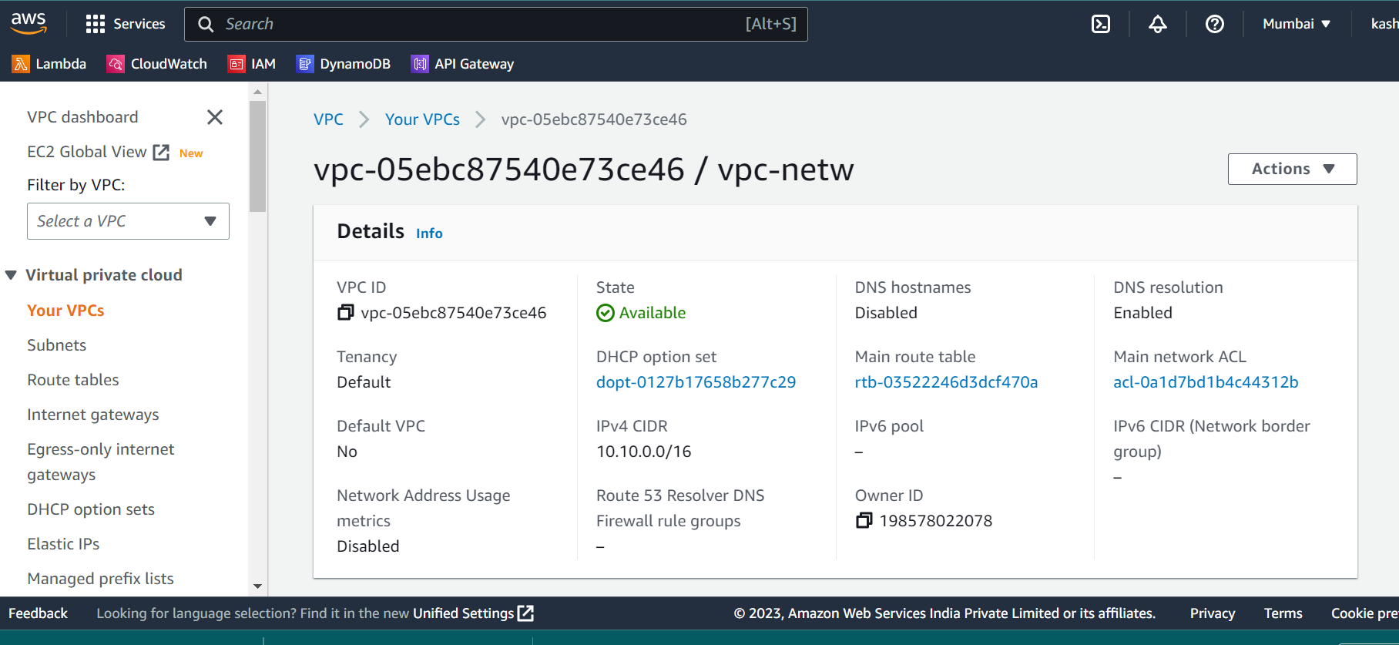

* 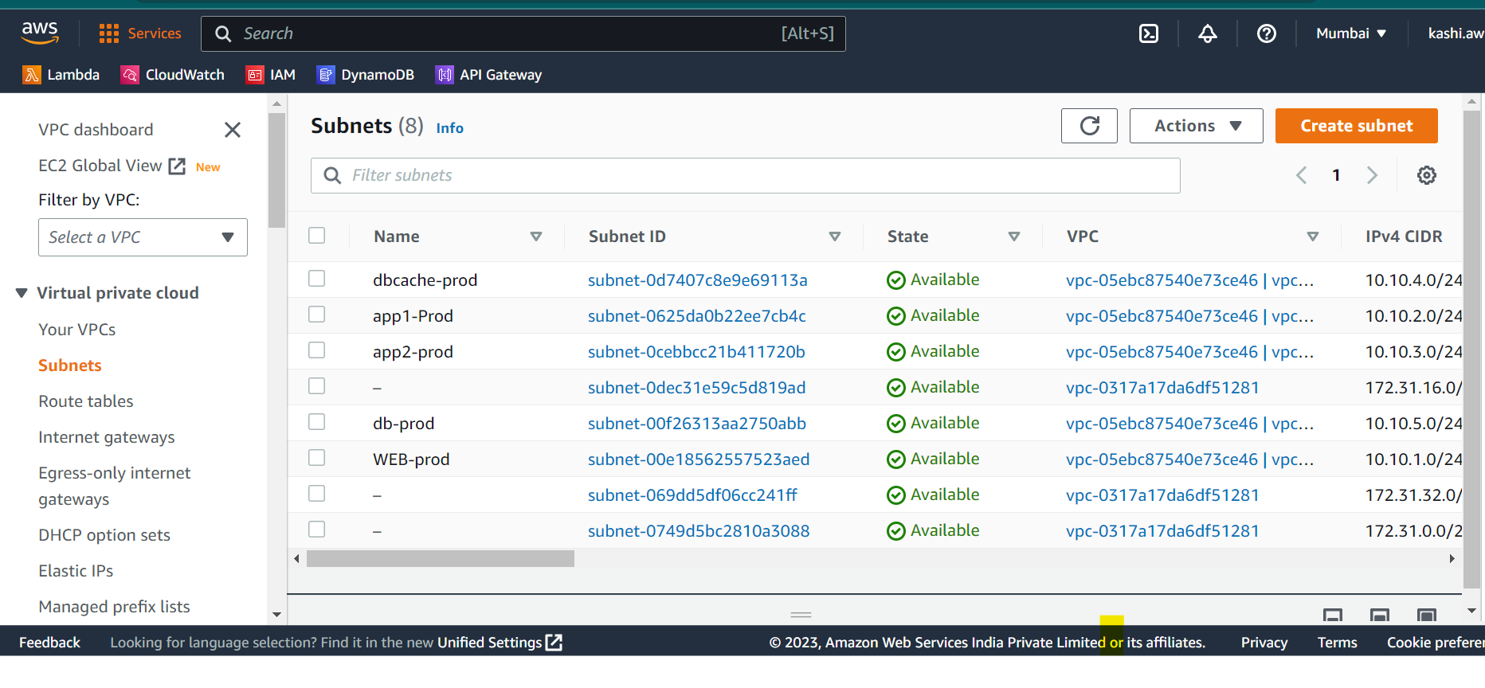
* **The creation of 5 subnets and WEB-prod is the only public subnet .**
* 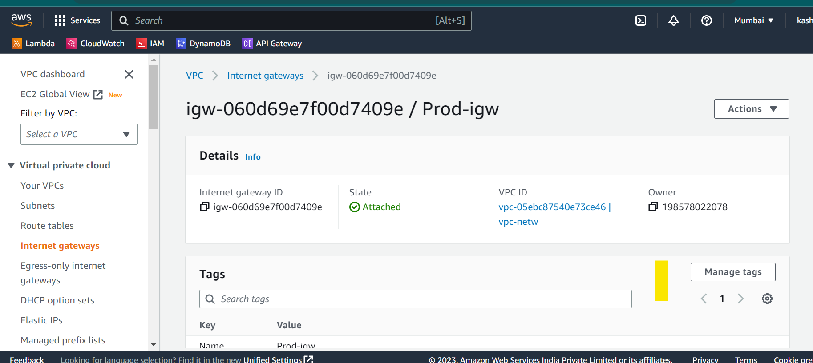
* **Internet gateway for Internet connection and attached to web-prod.**
* 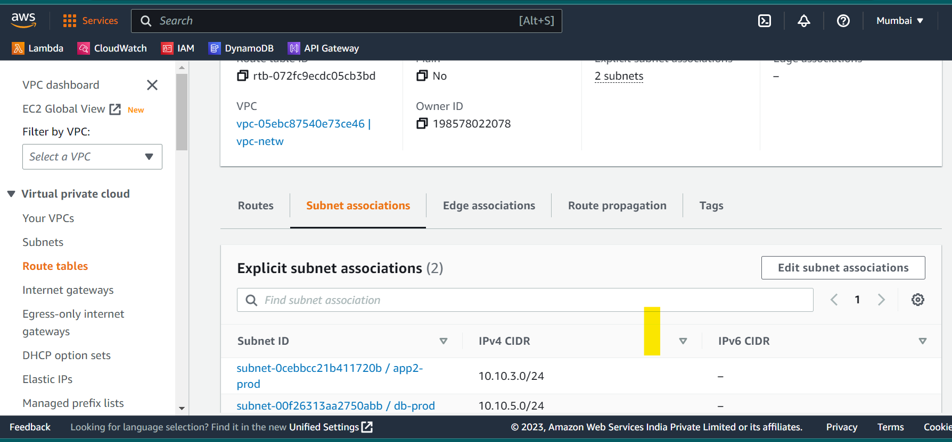
* **Route Table with internet and associated 2 subnets app2-prod and DB-prod**
* 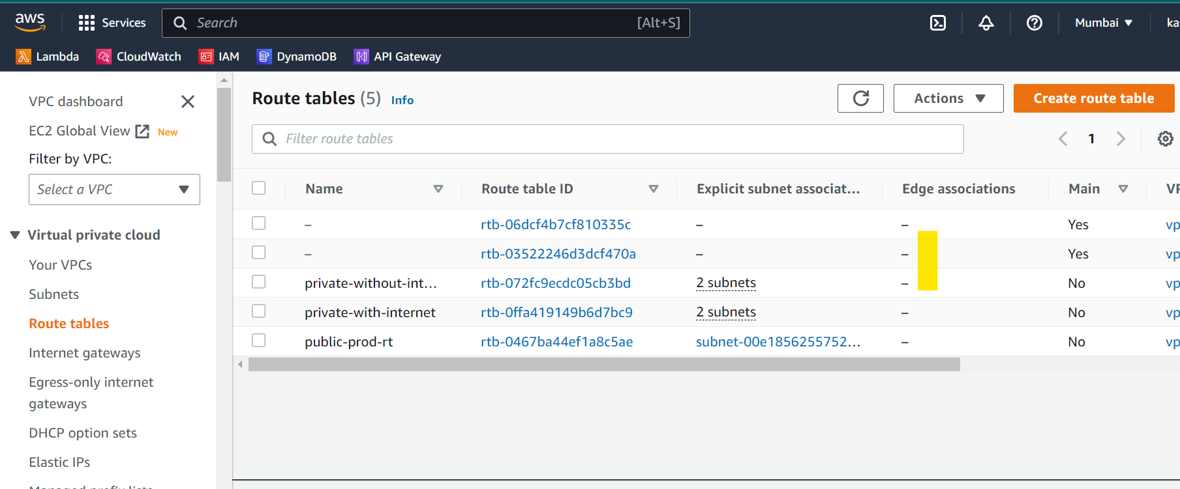
* **3 Route tables are created and associated with subnets .**
* 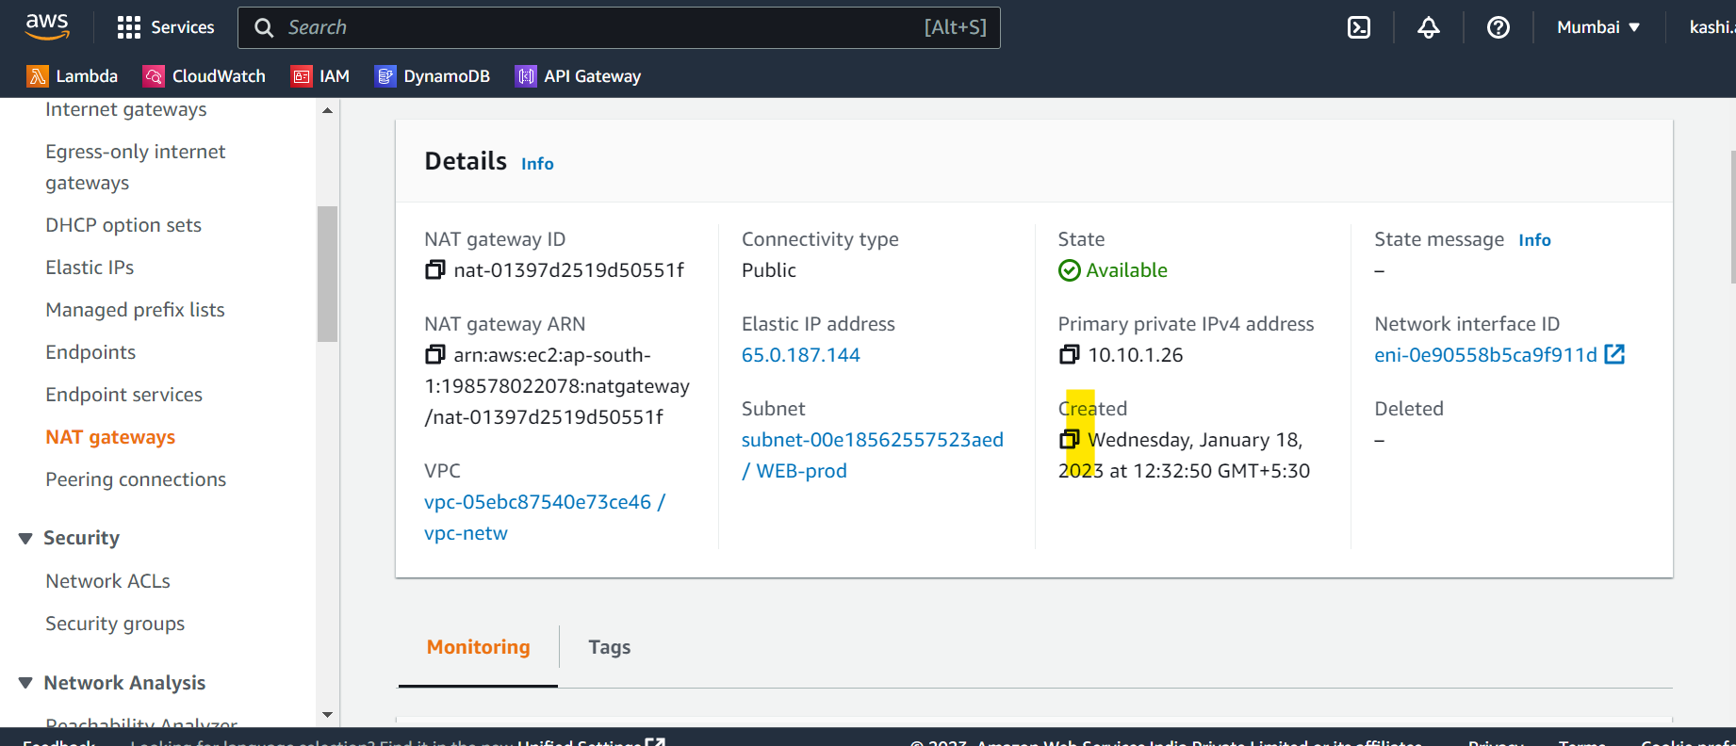
* **NAT Gateway is created for web-prod(public) as to communicate with private instances once created .**

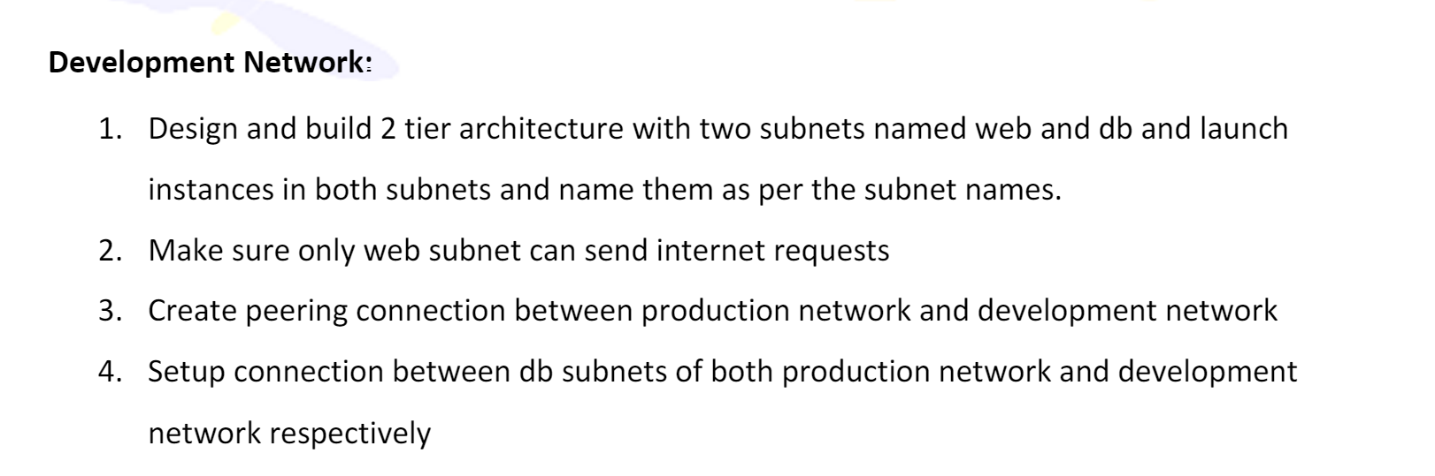

* **Created a VPC**
* 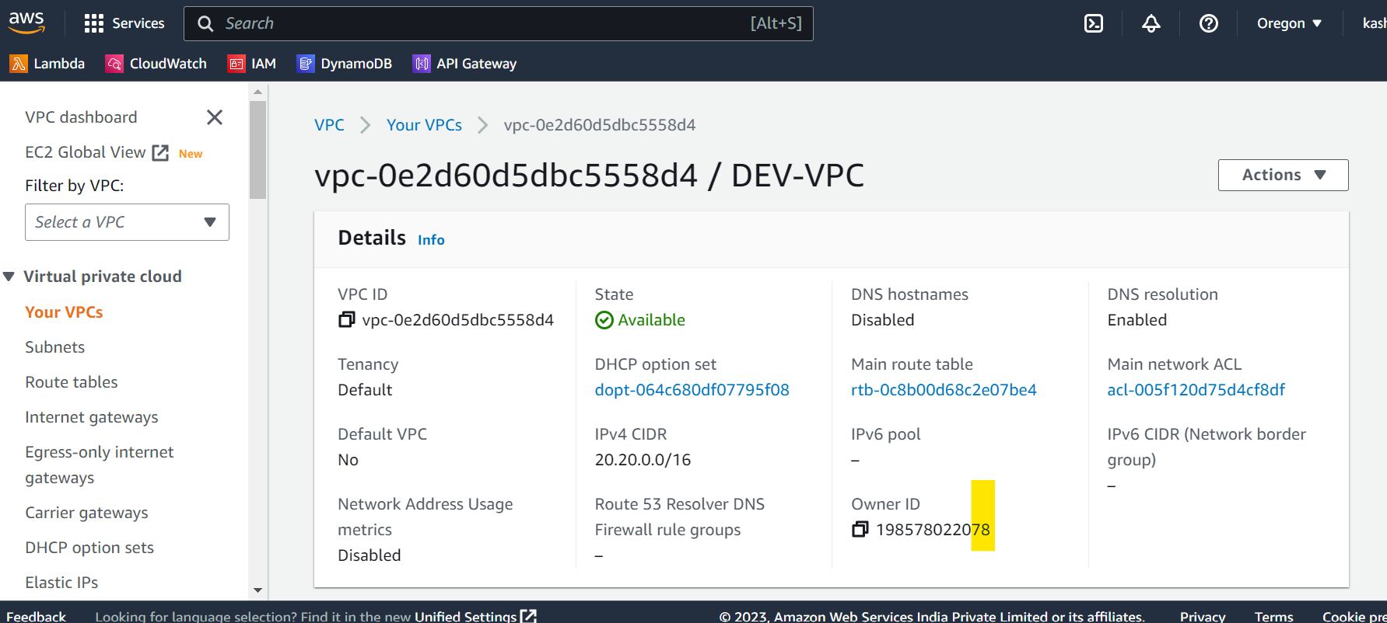
* **WITH 2 subnets**
* 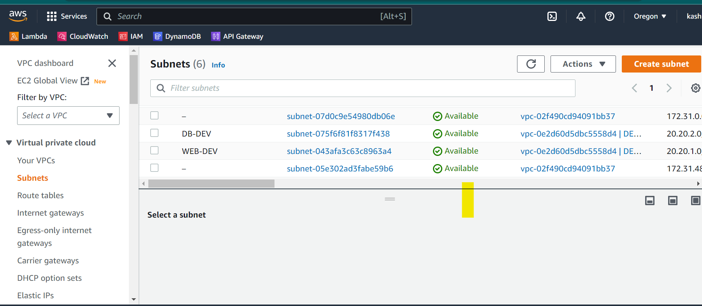
* **Internet Gateway with attached vpc**
* 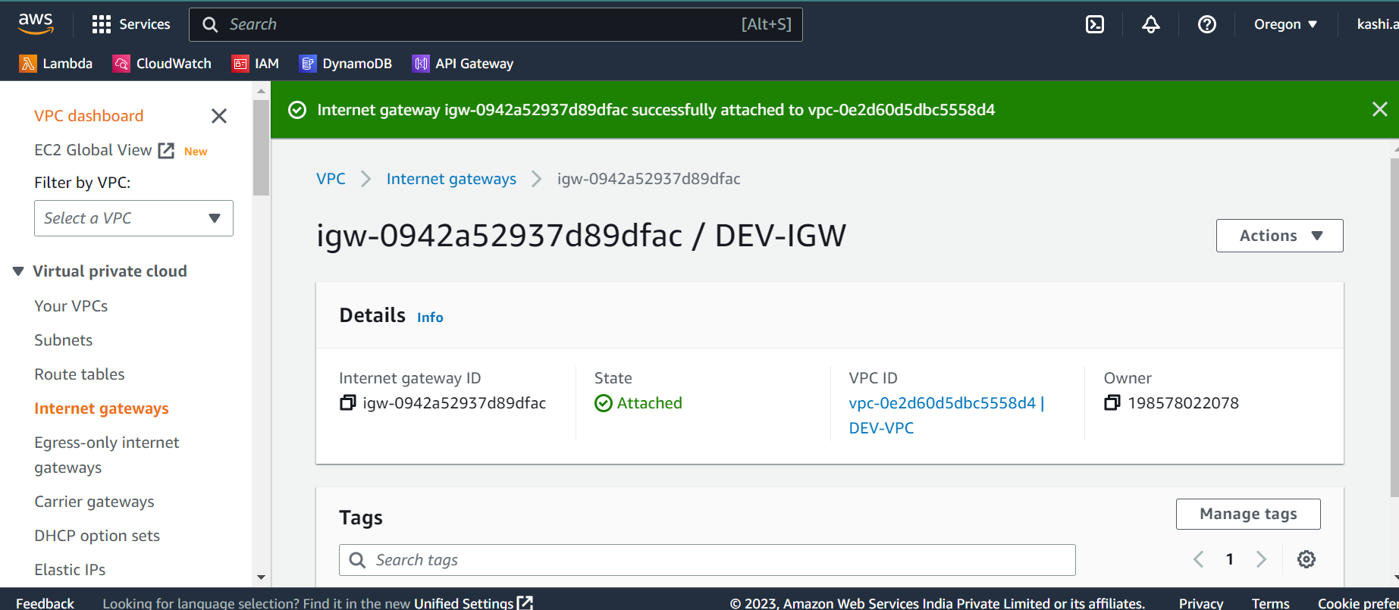
* **Route tables**
* 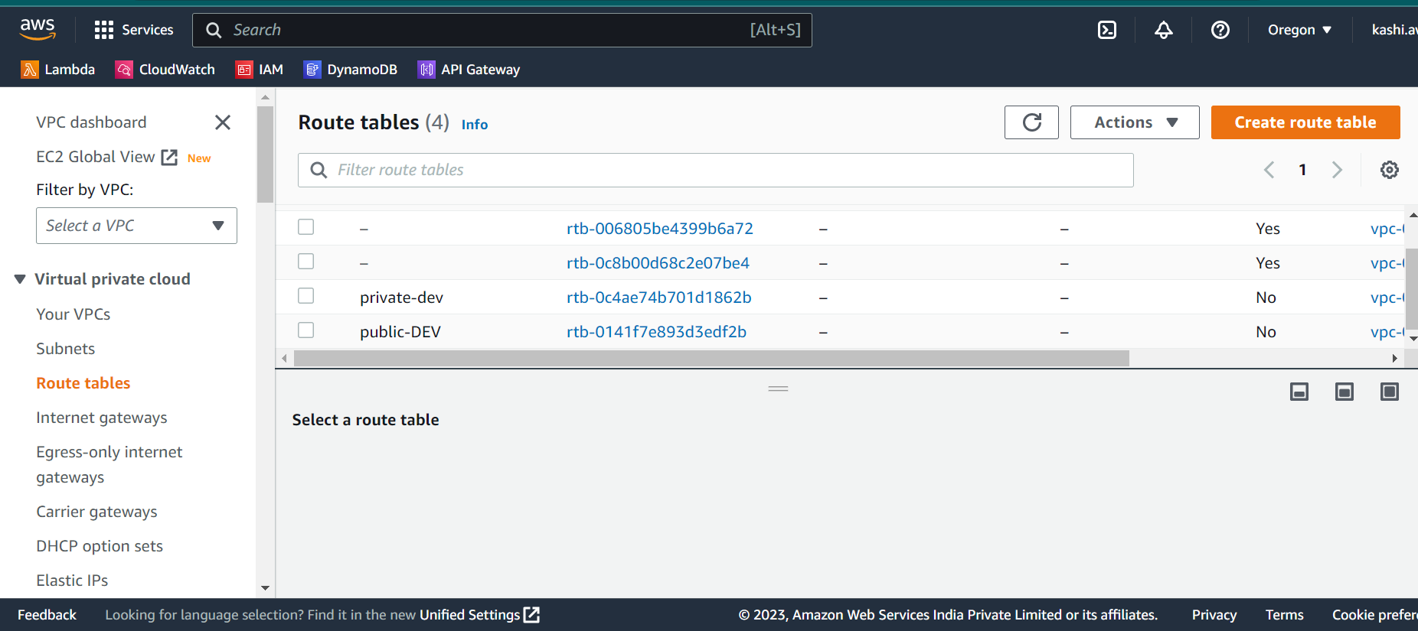
* **Public route table is associated with dev-prod subnet and connected with Internet Gateway**
* 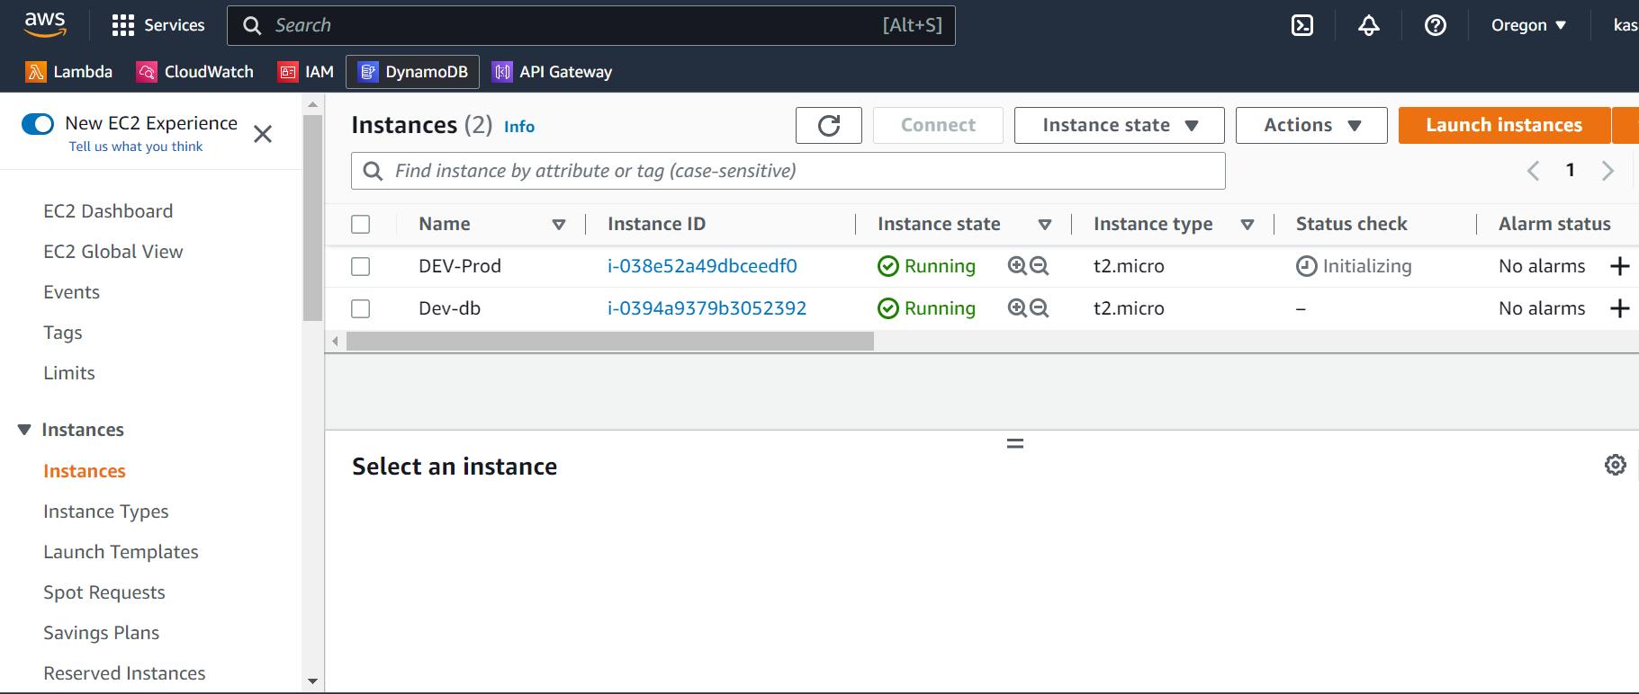
* **Instances are created in Oregon region**
* 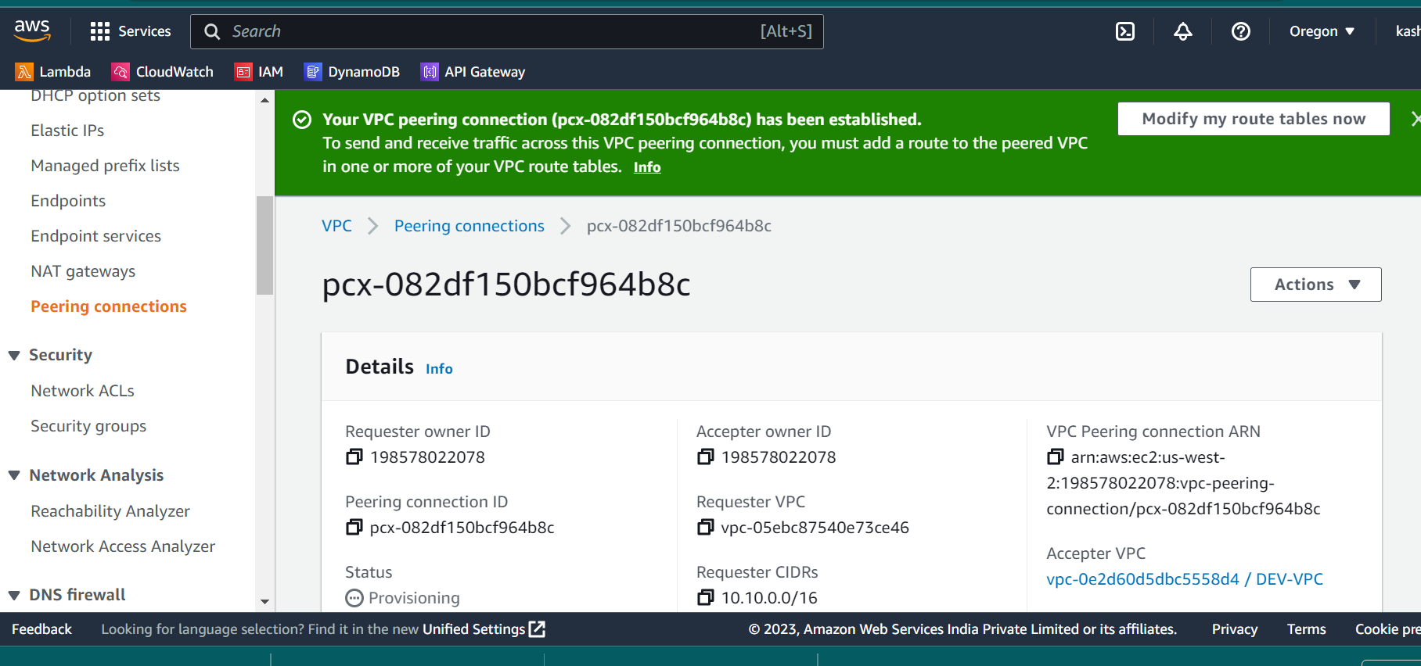
* **Created Peering connection between Oregon and Mumbai region and**
* 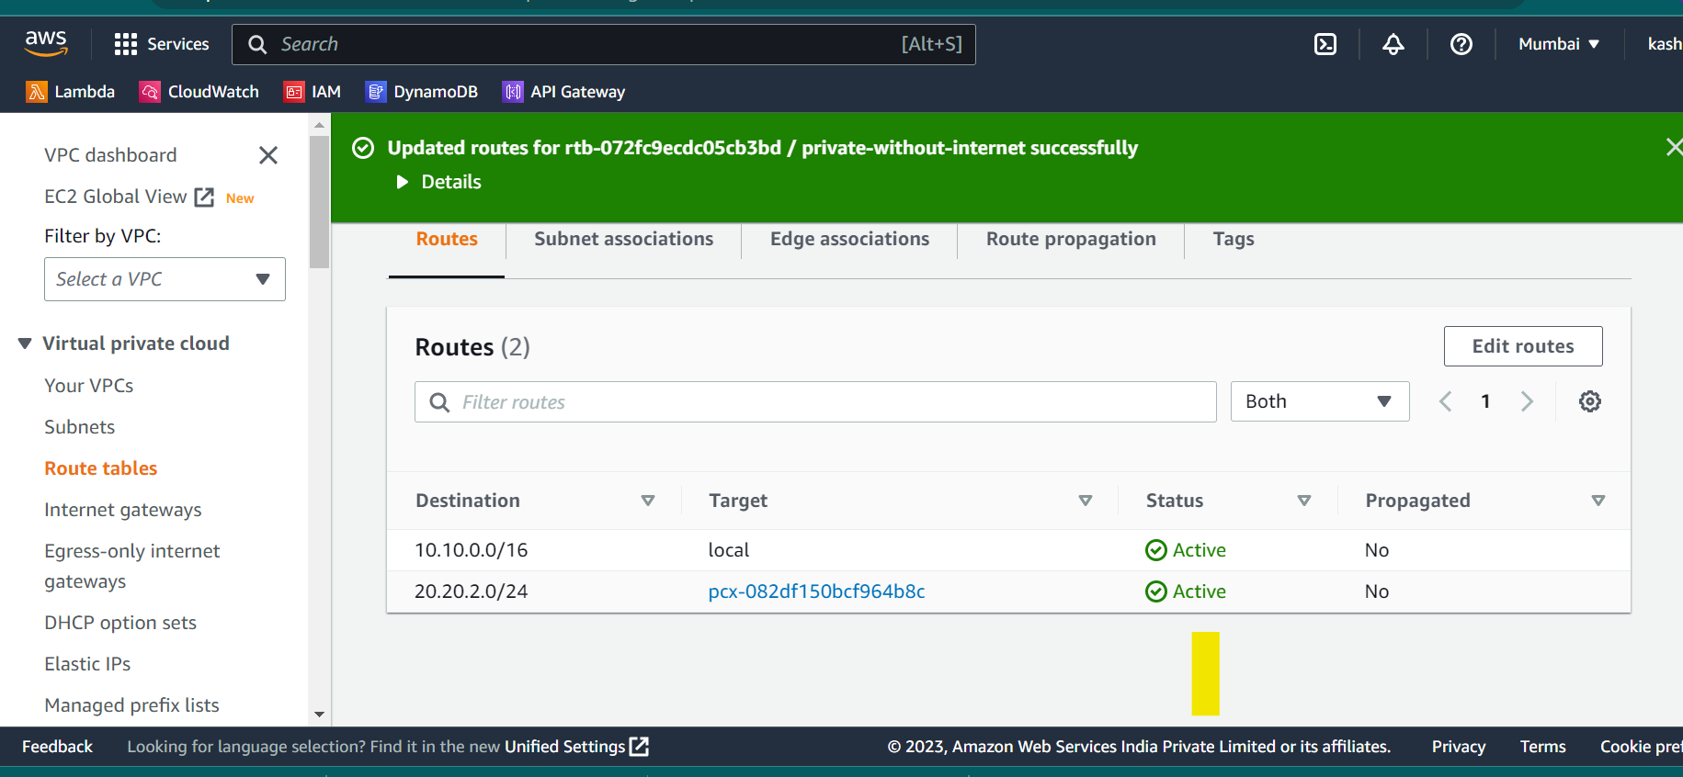
* 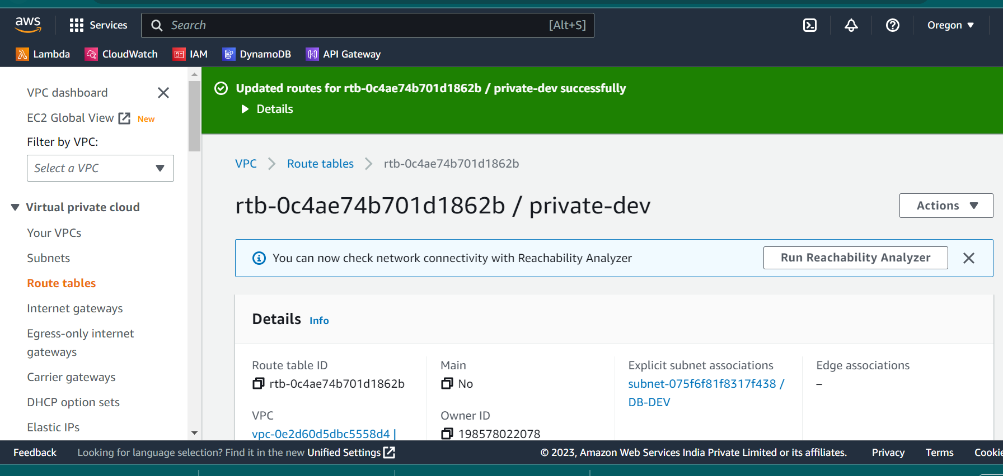
* **Route table is edited with the route**
* 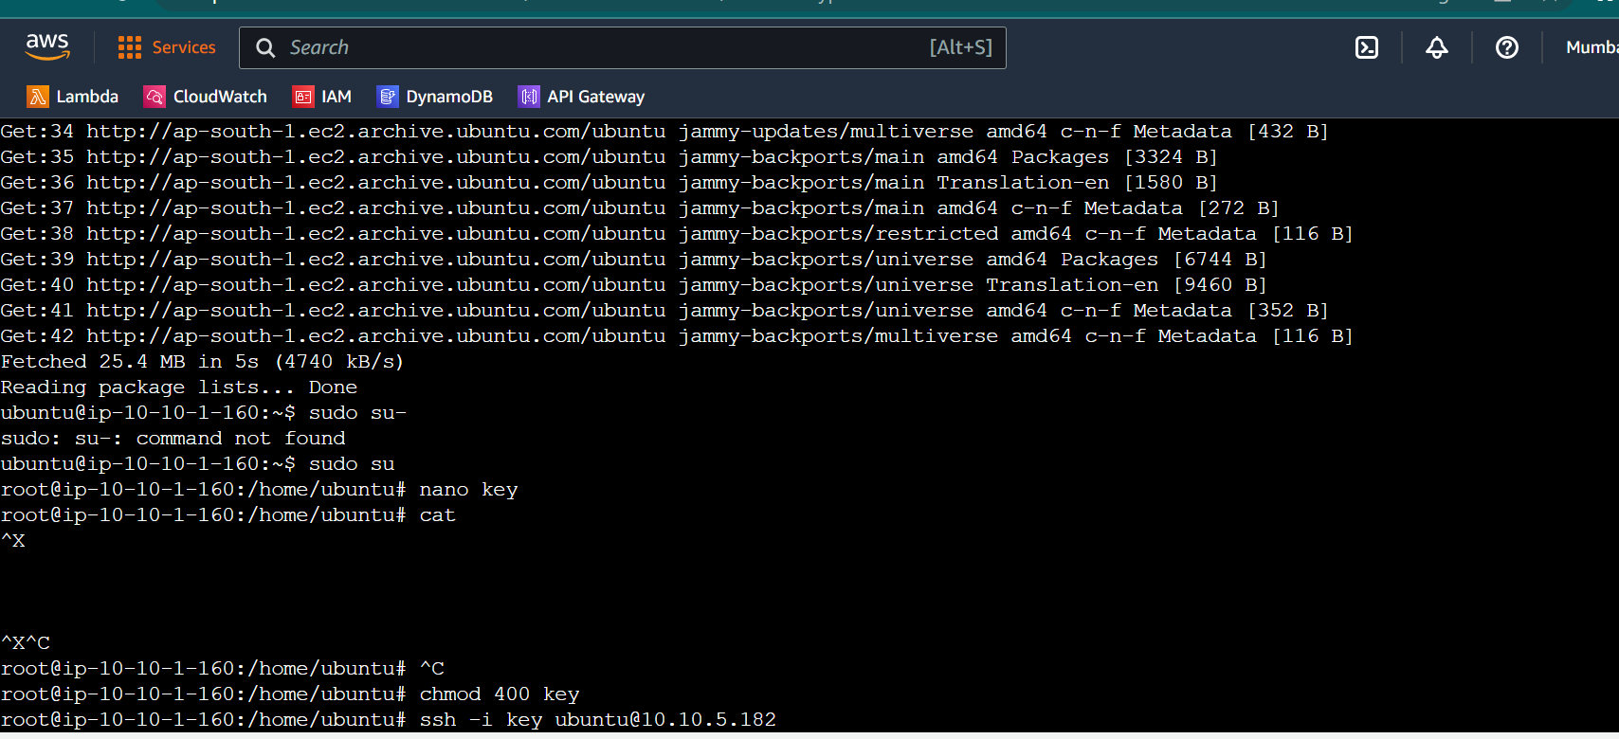
* **Same is checked by using ping for Oregon**

**Assignment -1**

1. **Create VPC With 120.0.0.0/16 CIDR Block**

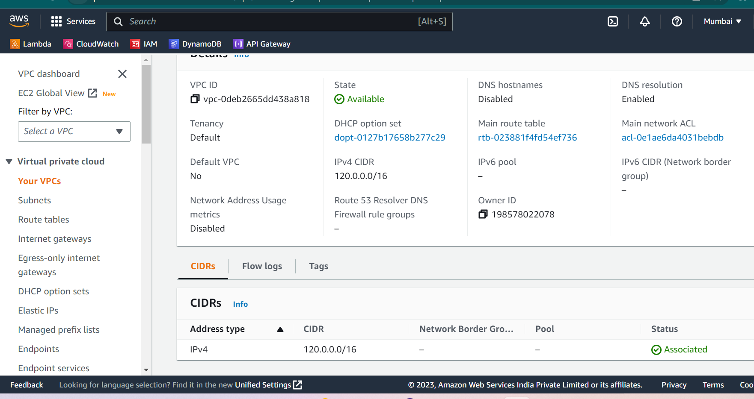

**2.Create 1 public and 2 private subnet and NAT gateway for private subnet .**

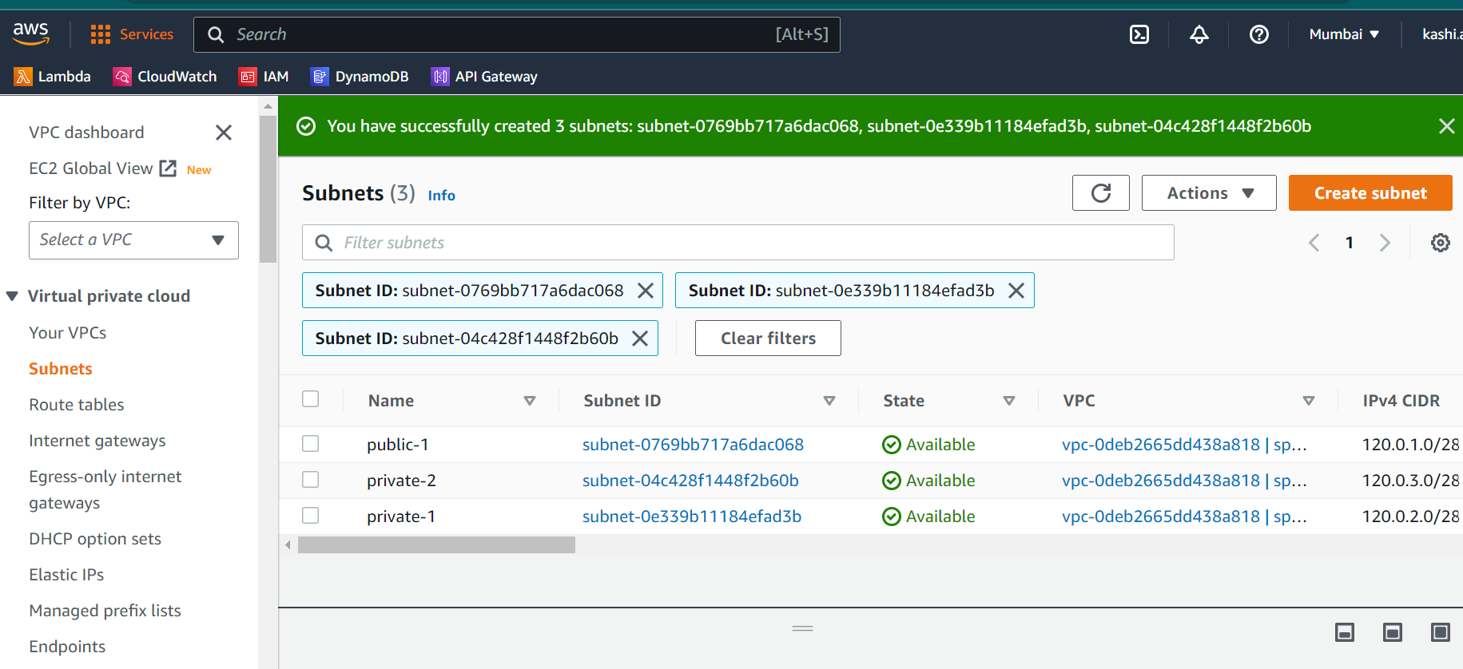

* **2 private and 1 public subnet are created with IPV4 CIDR**

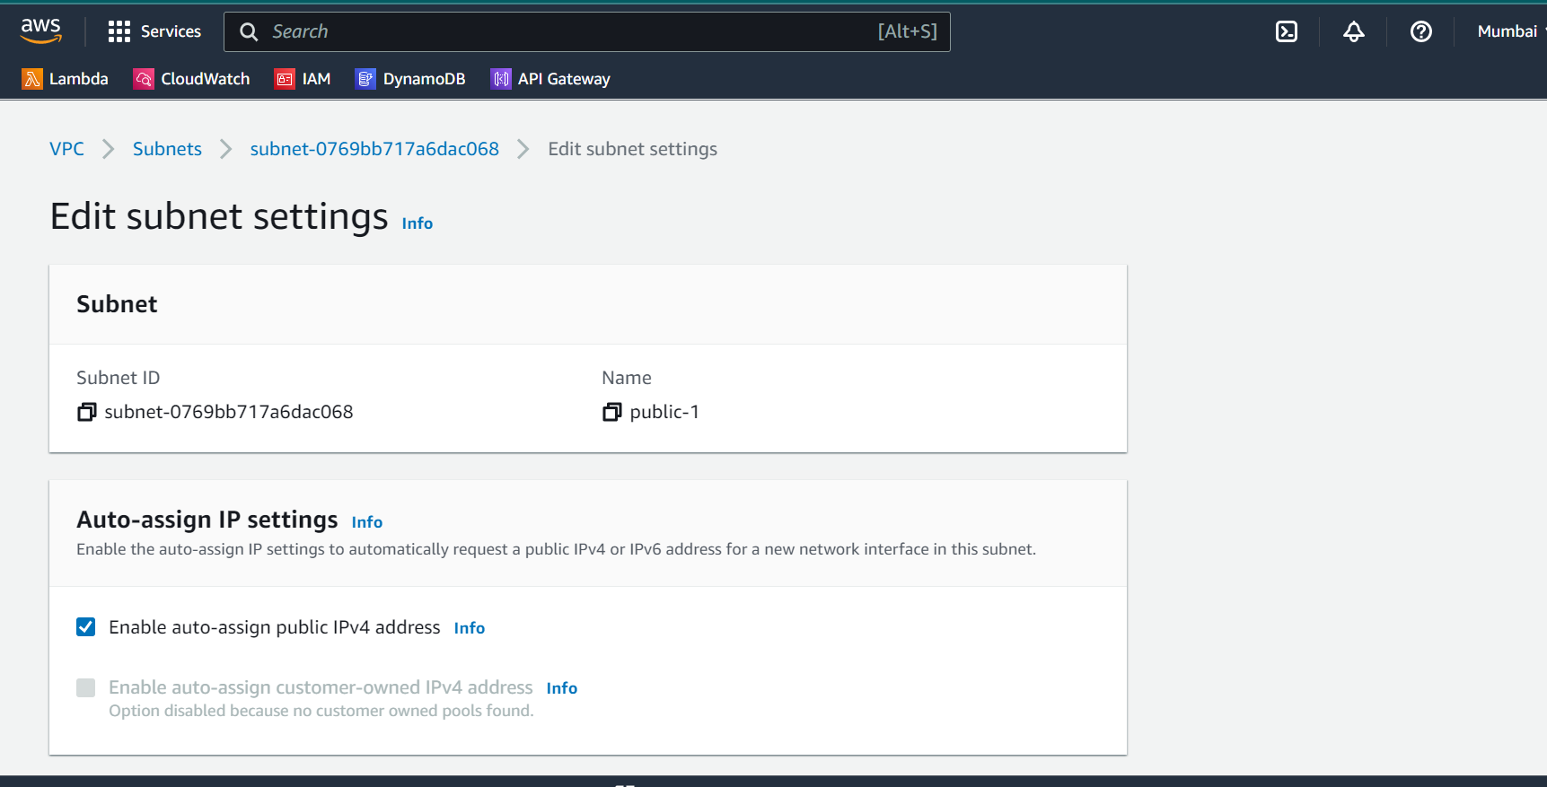

* **The public subnet is enabled to receive IPV4 / IPV6 addresses publicly**
* **Creating NAT Gateway in the public subnet for the private subnets to communicate with internet.**

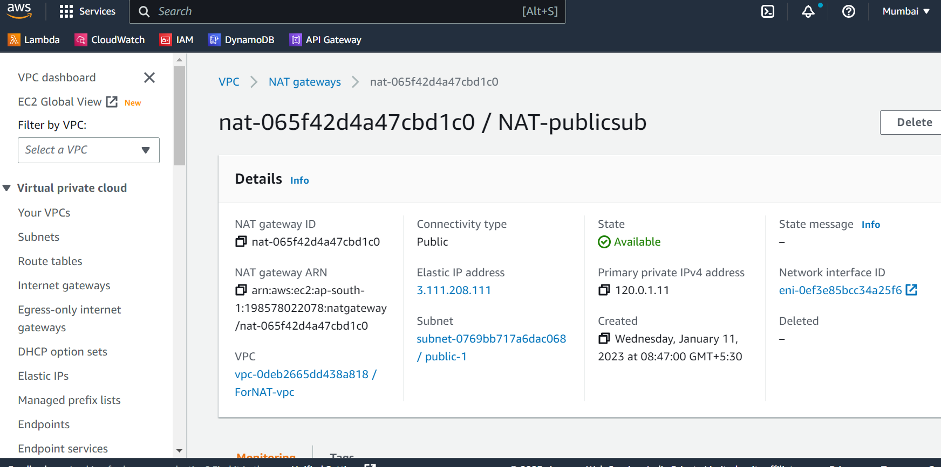

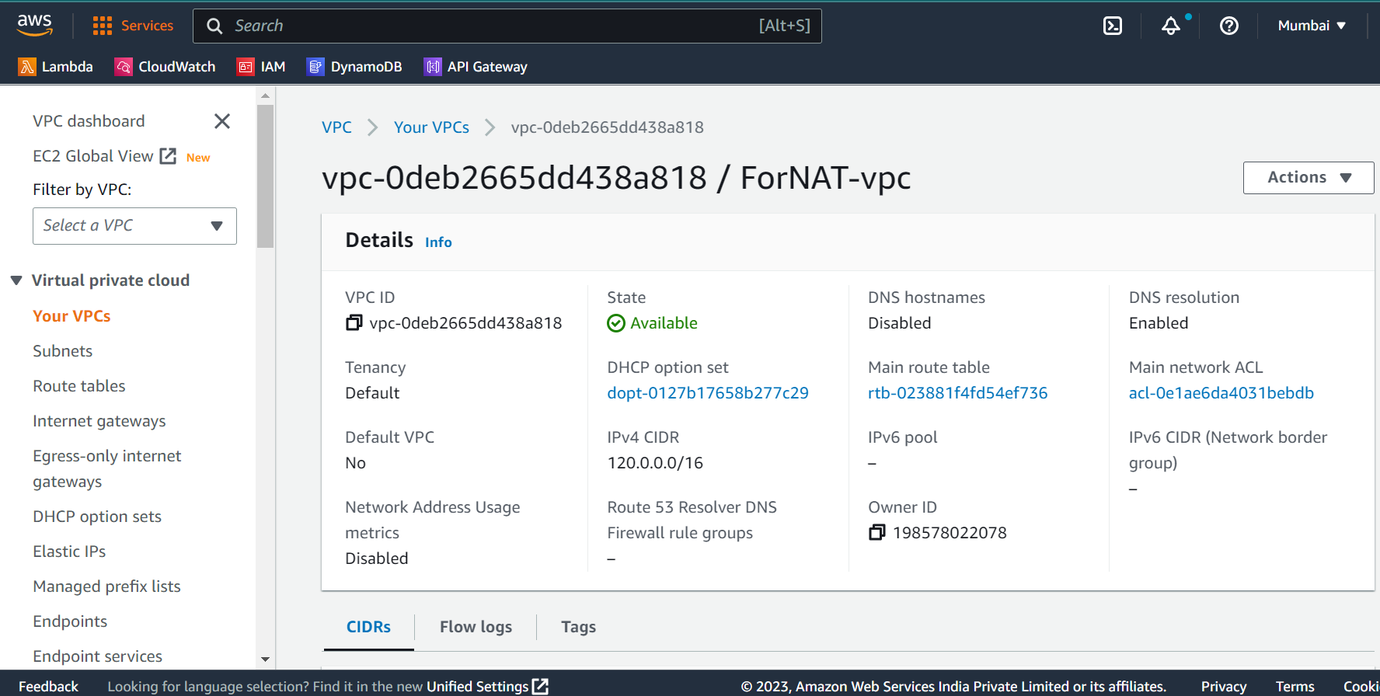

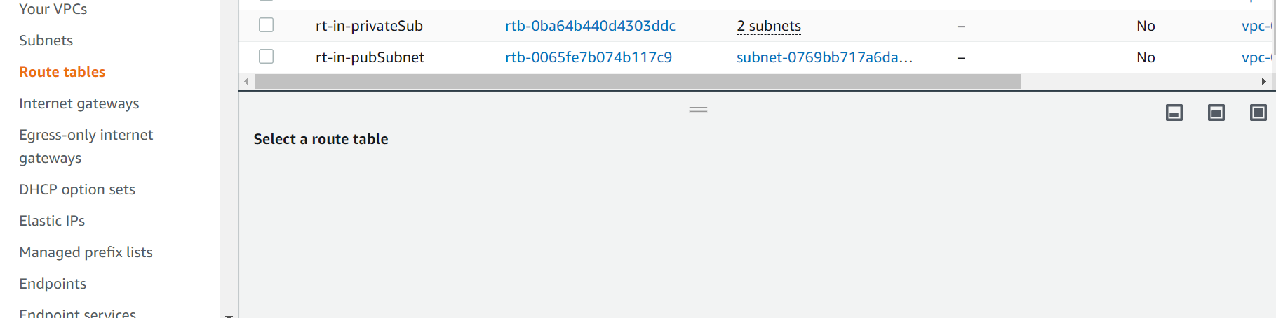

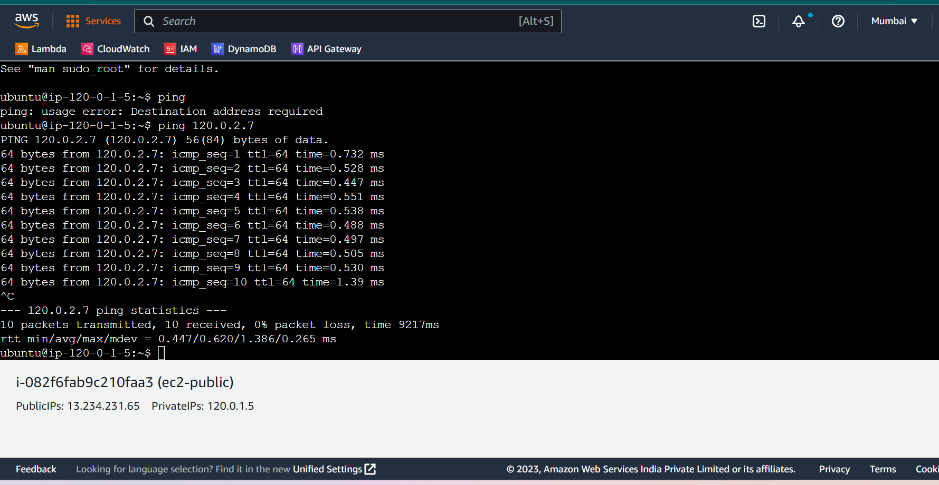

**Assignment 2**

1. **Creating 2 vpc in n.verginia MYVPC1 and MYVPCC2**

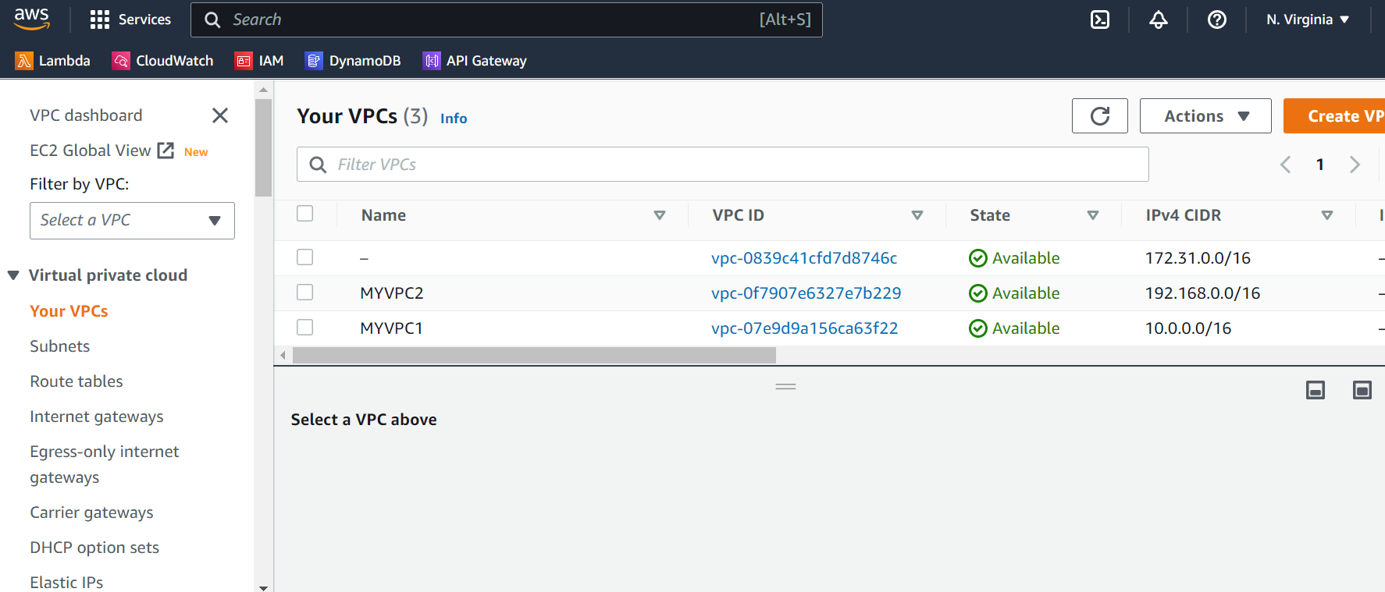

1. Create one VPC in Oregon region named VPCOregon1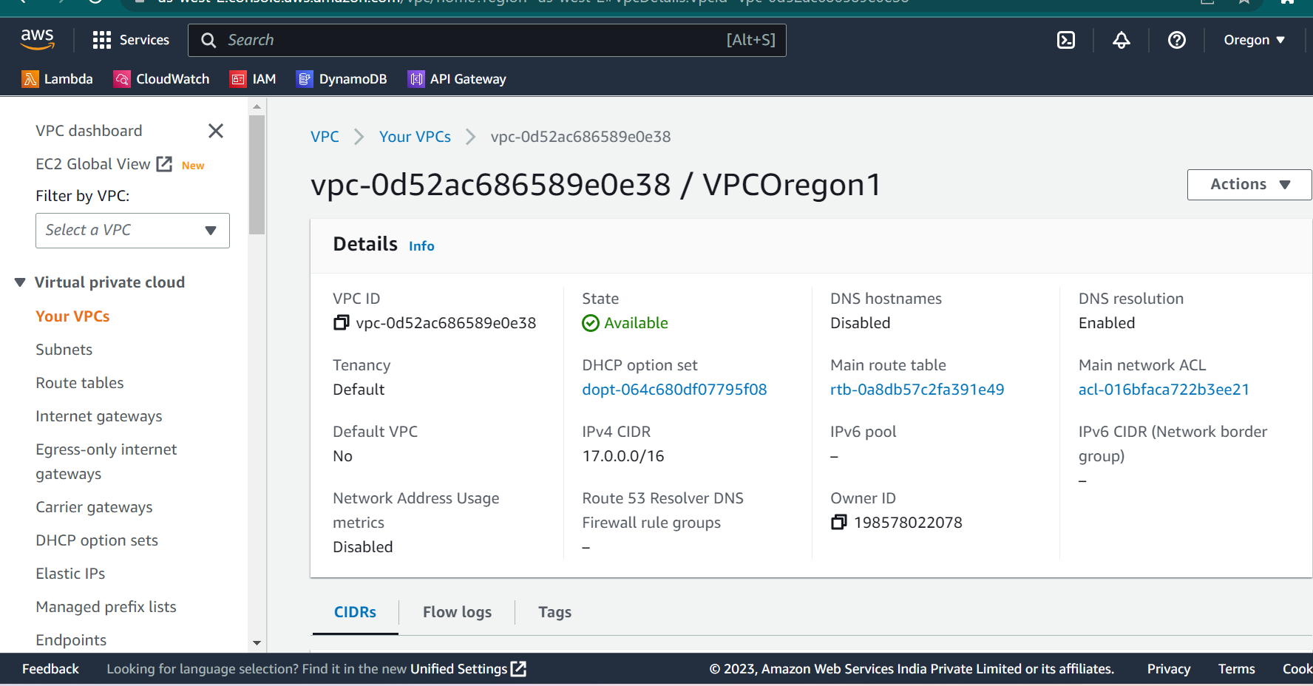

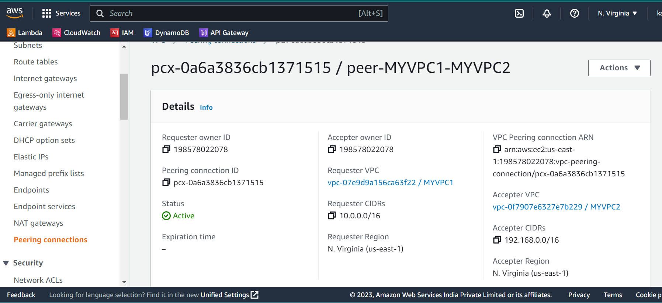

* Created 2 vpc MYVPC1 and MYVPC2 .
* Created subnet in both the VPC

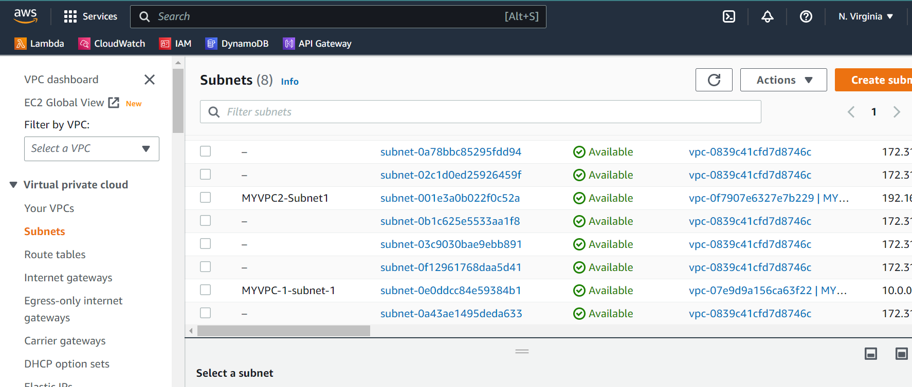

* Created Internet Gateway and route table respectively and with the help of ping command done the communication between peers MYVPC1 and MYVPC2

*# ERROR Faced 1 – peering gateway connection was not done in the route table*

*# ERROR Faced2 – ICMP traffic was allowed in the security group of the instances*

* 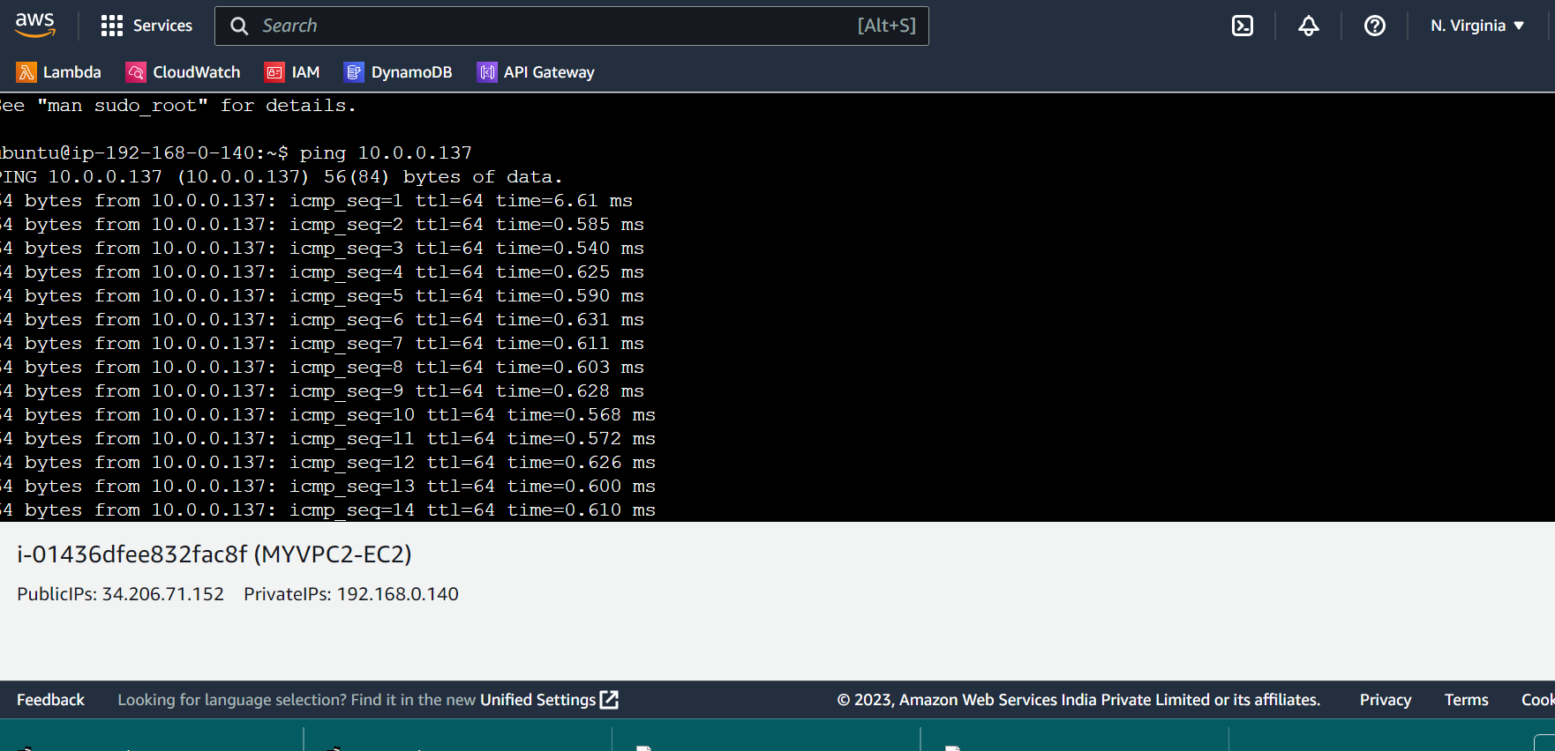
* 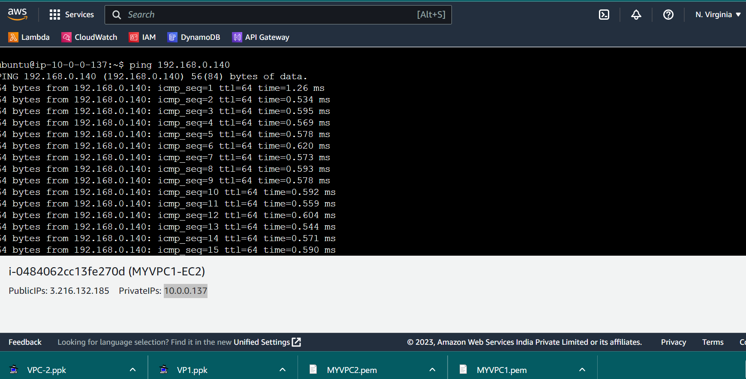
* The connection is successful.